1. 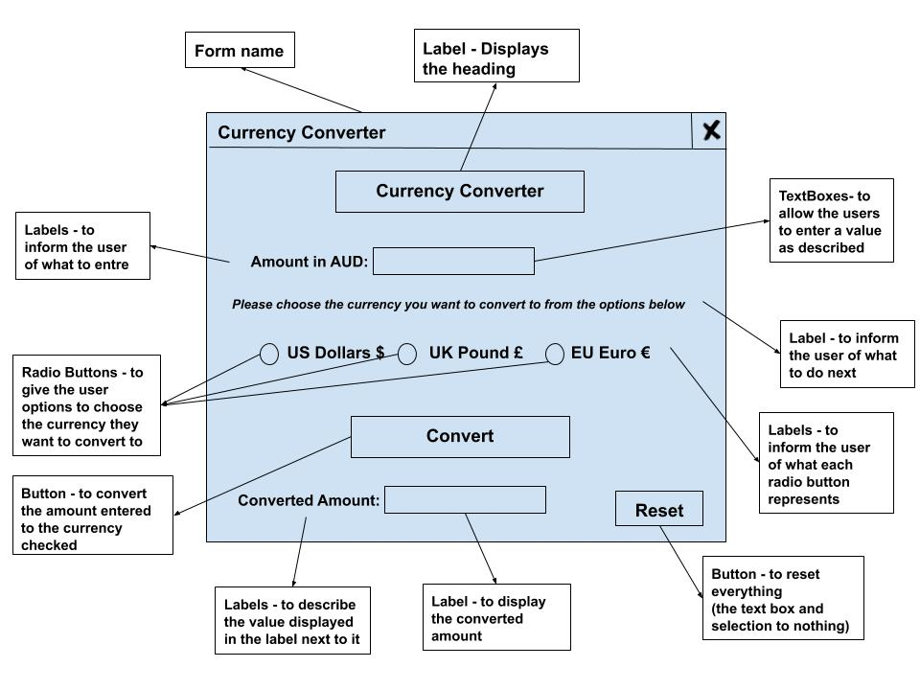**Mock-Up**
2. **Object Description:**

|  |  |  |  |  |
| --- | --- | --- | --- | --- |
| **Name** | **Type** | **Purpose** | **Attached procedure** | **Formatting information** |
| HeadLabel | Label | To display the heading of the program | - | Microsoft Sans Serif  Black - Bold  16 |
| AUDLabel | Label | To inform the user of what to entre | - | Microsoft Sans Serif  Black - Bold  11 |
| AUDTxtBox | Text box | To allow the users to enter the AUD amount | Convert() | Microsoft Sans Serif  Black - Bold  11 |
| InstructionLabel | Label | To inform the user of what to do next – i.e. choose an option | - | Microsoft Sans Serif  Black – Bold - Italic  9 |